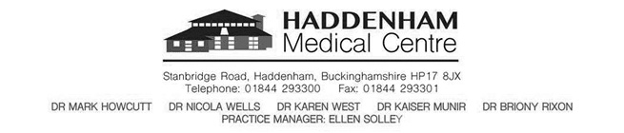**Opening Hours:**

**Monday-Friday : 8.00-18.00**

**Reception - Closed Daily : 12.30-1.30**

**www.haddenham.org**

**Haddenham Health News**

***Welcome to Haddenham Health News – an informative newsletter helping to keep patients informed!***

Spring is in the air!

Welcome to the Spring edition of our Newsletter – Winter has hopefully turned a corner and we can now look forward to longer days which also means the start of the pollen season. For those suffering from Hayfever this can mean the season of itchy eyes, runny noses

**Check if you have hay fever**

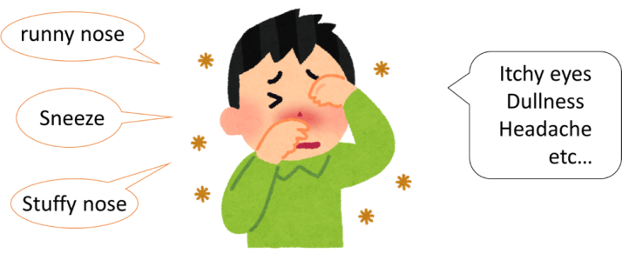 Additional symptoms of hay fever include:

itchy throat, mouth, nose and ears

loss of smell

pain around your temples and forehead

feeling tired

headache

If you have asthma, you might also: have a tight feeling in your chest

be short of breath

wheeze and cough

Hay fever will last for weeks or months, unlike a cold, which usually goes away after 1 to 2 weeks.

How to treat hay fever yourself

There's currently no cure for hay fever and you can't prevent it. But you can do things to ease your symptoms when the pollen count is high.

**DO**

* put Vaseline around your nostrils to trap pollen
* wear wraparound sunglasses to stop pollen getting into your eyes
* shower and change your clothes after you've been outside to wash pollen off
* stay indoors whenever possible
* keep windows and doors shut as much as possible
* vacuum regularly and dust with a damp cloth
* buy a pollen filter for the air vents in your car and a vacuum cleaner with a special HEPA filter

### DON’T

* do not cut grass or walk on grass
* do not spend too much time outside
* do not keep fresh flowers in the house
* do not smoke or be around smoke – it makes your symptoms worse
* do not dry clothes outside – they can catch pollen
* do not let pets into the house if possible – they can carry pollen indoors

Allergy UK has more [tips on managing hay fever](https://www.allergyuk.org/information-and-advice/conditions-and-symptoms/11-hay-fever-allergic-rhinitis).

## A pharmacist can help with hay fever

Speak to your pharmacist if you have hay fever. They can give advice and suggest the best treatments, like antihistamine drops, tablets or nasal sprays to help with:

* itchy and watery eyes and sneezing
* a blocked nose



**HAYFEVER MEDICATIONS AND PRESCRIPTION REQUESTS**

**PLEASE REMEMBER TO ORDER YOUR PRESCRIPTIONS AT LEAST 48 HOURS BEFORE THEY ARE REQUIRED ESPECIALLY OVER ANY BANK HOLIDAY PERIOD - PLEASE ALLOW A MINIMUM OF 2 WORKING DAYS FOR YOUR REQUEST TO BE PROCESSED.**

There are two repeat prescription boxes – 1 located outside main entrance and another in the foyer beneath the notice board. These are emptied at 8.00am and 11.00am – in all normal circumstances prescriptions received after 11.00am will be processed within the next 2 working days.

**We recommend where possible for patients to sign up for Patient Access – this will allow you to order your medication direct and can be far more convenient and time effective.**

**How do I sign up?**

* + - Bring in Photo ID – this can be a Driving Licence, Passport or Bus Pass or Student Card
    - One of the Reception Team will then print off your exclusive personal log-in data to enable you to access the system.

PLEASE NOTE YOU WILL NEED TO HAVE YOUR OWN INDIVIDUAL EMAIL ACCOUNT AS THE SYSTEM WILL NOT ALLOW SHARED EMAIL ACCOUNTS FOR PATIENT SECURITY REASONS

Access for children aged 12 and over will necessitate a routine telephone consultation with a Doctor before access can be made available.

**[](https://www.google.co.uk/imgres?imgurl=http://images.clipartpanda.com/travel-clipart-TN_plane_earth.jpg&imgrefurl=http://www.clipartpanda.com/clipart_images/free-travel-clipart-clip-art-5859606&docid=LAqkmYdq4BPu6M&tbnid=VIkDr-f_nMstEM:&vet=1&w=170&h=138&bih=929&biw=1280&ved=2ahUKEwjNl9fenILaAhWKDywKHXZmBd8QxiAoBXoECAAQFg&iact=c&ictx=1)TRAVEL CLINICS**

This time of year you may be planning your Summer holidays – now is the time to plan ahead for any immunisations you may need. We offer a Travel Clinic at the Surgery but appointments can be limited and are on a first come first served basis. We therefore recommend that you think ahead for any requirements you may need. It is IMPORTANT that you follow our booking procedure which is as follows:

Complete a Travel Risk Assessment form which can be downloaded off of our website or collection from Reception.

[](https://www.google.co.uk/url?sa=i&rct=j&q=&esrc=s&source=images&cd=&cad=rja&uact=8&ved=2ahUKEwjn08m3nYLaAhUDDSwKHchkClsQjRx6BAgAEAU&url=https://www.123rf.com/photo_21435390_cartoon-illustration-of-syringe-with-medicine-clip-art.html&psig=AOvVaw17g8km1UbZAJCEHBo2OglH&ust=1521887081871085)Upon completion bring the form into Reception and book your appointment in one of our Travel Clinics. These appointments will only be booked upon receipt of the Travel Risk form.

Please book your appointment a minimum of 6 weeks before your due travel date.

General Travel Health Requirement Information may be obtained from MASTA Travel Health- 0330 1004106. In addition to our service there is also The Oxford Travel Clinic and JMW Vicary also provide a Travel Clinic Service.

 **AWARD**

## http://www.gpwebsolutions-host.co.uk/14854/files/2019/03/haddenham.jpgRCGP Armed Forces Veteran Friendly accredited GP practice



**CARE NAVIGATION Where do I get the right support?**

The surgery has 3 trained Patient Care Navigators who will be able to assist with questions and advice and to point you in the right direction to get the correct and any support for yourself and any loved ones. They are Trish Kearns - Reception Manager, Tamsyn Doel and Suzi Labross. They can assist with non-clinical advice, guidance and help on services which may be available to you and point you in the right direction ie. Carer needs; sourcing mobility aids; financial assistance etc.



**MEMORY INFORMATION SESSIONS**

On Tuesday 21st May the surgery will be holding a Memory Information Session

Are you worried about your own memory or know someone else who is? Do come

along. Information covered will include understanding memory, tips and coping

strategies and local help available.

Contact Angela Walshe on 01296 331749 for more information and to register a place.

[](https://www.google.co.uk/url?sa=i&rct=j&q=&esrc=s&source=images&cd=&cad=rja&uact=8&ved=2ahUKEwj3ppmcwaLhAhVIgM4BHewvBdIQjRx6BAgBEAU&url=https://www.bucksfamilyinfo.org/kb5/buckinghamshire/fsd/service.page?id%3DrEnwd0J8ozI&psig=AOvVaw3aieUk3U3A0V24J-IWK8Kq&ust=1553782541209902)**MANAGING TYPE 2 DIABETES**

Livewell Staywell is a free lifestyle support service that can also help you to lose weight, quit smoking be more active and support you with the emotional challenges of

managing your diabetes.

Courses are available over 4 week periods at various venues throughout Bucks and are ideal for people to attend in person who want to meet other people living with diabetes in their area for peer support.

Further details can be found at

[www.livewelstaywellbucks.co.uk](http://www.livewelstaywellbucks.co.uk) or

01628 857 311 or email info@parkwoodhealthcare.co.uk

**DATES FOR THE DIARY**

Tues 30th Apr 2019 PLT surgery closes 12.30

Thurs 2nd May 2019 PPG Patient Access Training morning 10.00am

Weds 8th May 2019 PPG meeting 7.00pm

Tues 21st May 2019 Memory information session

Weds 22nd May 2019 PLT surgery closes 12.30

Weds 19th June 2019 PLT surgery closes 12.30

Tues 9th July 2019 PLT surgery closes 12.30

**Tyrefighters Weight Loss Drop in Sessions are normally held during Saturday surgery opening commencing at 9.00 am.**

***Extended Hours***

* Sat 6th April 2019 Sat 15th June 2019 Sat 17th Aug 2019
* Sat 27th April 2019 Sat 6th July 2019 Sat 7th Sept 2019
* Sat 11th May 2019 Sat 20th July 2019 Sat 21st Sept 2019
* Sat 18th May 2019 Sat 3rd Aug 2019
* Sat 8th June 2019

**NEW STAFF**

We welcome Dr Louise Thompson who has joined our Team as an ST2 and will be here up until August 2019 together with Dr Dawn Edwards who has also joined as an ST3 who will who will also be here until August 2019. Debbie Smith has also joined our teams at the surgery as Accounts and Admin Assistant.

**Connie’ Colander**

Patient Group (PPG)

A first for the Patient Group! The Human Story Theatre will be performing a play for us at the Haddenham Library on 22nd May at 7.00pm. Admission is FREE and open to all.

Connie is a retired domestic science teacher. Emily, her daughter, is enjoying hosting her first TV cookery show: Connie’s Colander, bringing her mother’s recipes onscreen and up to date. Sensitively, with humour and tenderness this newly written play traces the evolving relationship throughout their lives, and the impact of Connie’s Alzheimer’s. Can their relationship, and the TV show, survive?

Thanks to Support from the Bucks CCG and the Arts Council we are able to make Admission FREE!

Pick Up a Ticket from Haddenham Library or Register online at conniestickets.eventbrite.co.uk Hurry seats are limited!

**Join your Patient Group Now!**

There is no charge for membership of the patient group and you can register in a couple of minutes. You will receive regular news about meetings, events, and the Medical Centre. Just go online to:

[www.hmcppg.com/joinppg.php](http://www.hmcppg.com/joinppg.php)

**What did the Patient Group do in 2017?**

Thanks to our Working Group Members: Jan Backhouse, Gill Bedding, Lesley Coles, Bob Giles, David Gregory, Sivaswami Nagraj, Brian Rogers and Ellen Solley

* We completed Phase 1 of Dementia friendly signage in the Medical Centre raising £3,000 of donations to fund the whole project
* Through our fundraising lottery The PPG 200 Club we purchased for the Haddenham Medical Centre a Fingertip Pulse Oximeter (Paediatric), 2 Multi Reading/Recording BP monitors and 2 additional High-Backed Armchairs for reception.

* We increased our membership by 100
* We launched Training Sessions for Patients in the use of the “Patient Access” system for online prescriptions, appointments and medical records.
* We Introduced regular specialist speakers at PPG meetings and raised funds to put on the playlet by Human Story Theatre about Dementia to be performed at Haddenham Library (see above)
* Established Terms of Reference for the Patient Group which were approved by the membership.

**The Patient Group, U3A, and the Medical Centre back Social Prescription**

Retired people make up 25% of the population. They consult their GPs three times more often than the rest of the population. Progress in medical science is continuing to further prolong our lives at a cost the NHS cannot afford. Social Prescription can provide a way of reducing these costs.

**What is Social Prescription?**  
Put simply, it means that instead of prescribing medication and medical procedures, the GP prescribes life-style changes as an alternative.

For example, diet, exercise and social interaction: type 2 Diabetes can be reversed by diet and exercise. Loneliness is a major cause of depression and a factor in the development of Alzheimer’s Disease. Diabetes and its complications alone cost the NHS £10 billion p.a. Eight percent of patients in the UK suffer from Diabetes and this figure is rising. Social interaction and exercise can be of great help in improving these conditions.

**The Haddenham Initiative**The Medical Centre, the Patient Group and the U3A have joined forces to introduce a pilot scheme for Social Prescription. GPs at the health centre will have on their personal screens details of about the thirty interest groups offered by the Haddenham U3A. GPs will advise patients of the interest groups which are appropriate to their needs as an alternative to medication. The pilot scheme is being monitored by the U3A national headquarters with the possibility of rolling out the scheme nationally. If successful, this scheme could not only improve the well-being of many patients but also significantly reduce costs to the NHS.

Look at our new U3A/Patient Group notice board at the Medical Centre (on the right on your way out) with leaflets containing details of the U3A interest groups and how to join.

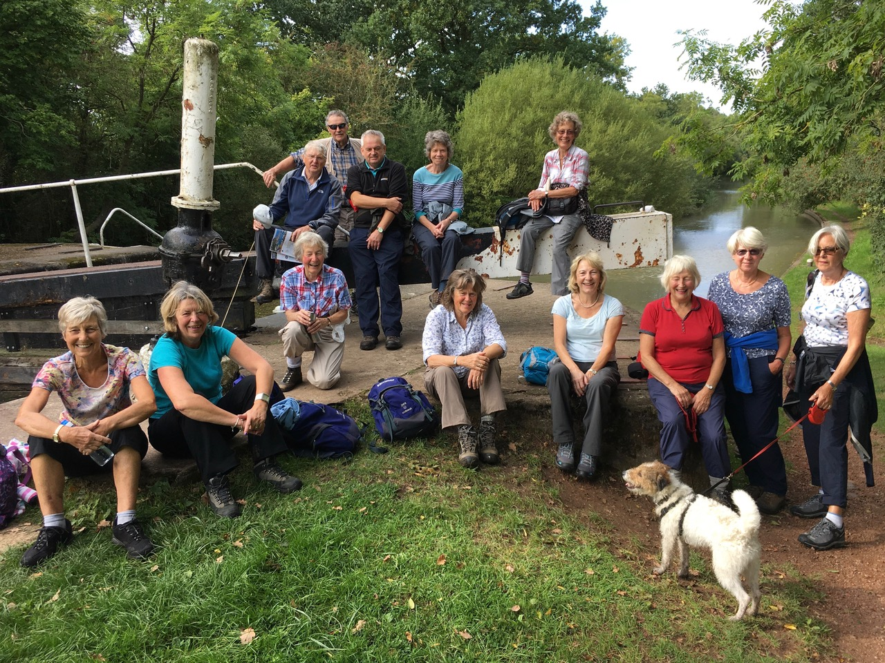

**HELP YOURSELF TO GOOD HEALTH**



Many patients will be aware of the website and mobile-phone App entitled Patient Access which was designed to provide users with an online facility enabling them to access a range of GP services digitally. This includes the ability to make and cancel online appointments (including telephone appointments), request repeat medication from a pharmacy of an individual’s choice, check immunisation history, and in many cases read test results and consultant’s reports. There are also a number of videos and online articles available to explain medical terms and provide A group of people sitting at a table in a room
information related to a wide range of treatments and medical issues.

Unfortunately, for a variety of reasons, when it was first rolled out many people found difficulty logging into the Patient Access system. When they did eventually manage to gain access, they found the menu system difficult to navigate, not helped by frequent changes in the software and menu links. The software contractor has since produced some online help links designed to assist patients in using the system, but Haddenham Medical Centre’s Patient Participation Group continues to receive many reports of confusion and difficulty in its use. As a result, a few of the PPG’s members decided to put together a short (approx. 1hr) training programme which, thanks to the Practice Manager, they now run in the Medical Centre itself. This has allowed the PPG trainers to identify quickly any registration problems and with the cooperation of the knowledgeable reception staff, rectify individual difficulties on the spot. However, during the first session, it quickly became apparent that the Patient Access software was not always the problem. Several potential users misunderstood the administrative process necessary to gain logging-in authorisation whilst others had difficulty logging into the Haddenham Medical Centre Wi-Fi Network to start the training session. Others found difficulty operating their own individual IT devices, whether it was a laptop, mobile phone or iPad, so a degree of IT coaching and assistance using their chosen device was also provided.

A number of other initiatives have been taken by the PPG, one of which was to produce an explanatory leaflet which outlines the administrative steps necessary to Register with, and log into, the system.

So far, the Group has conducted 3 successful training sessions and is hoping to help many more people to get logged in using their own IT devices and gain confidence in using Patient Access. It is hoped to equip as many people as possible with the knowledge and skill to make better use of Patient Access as it can provide an efficient way of communicating with the Medical Centre which both benefits the individual and the practice.

**The Next Free Training Session for Patient Access will be on**

**2nd May 2019 at 10.00am at the Medical Centre**